New Application Change of Bank Cancel Authorization
Employee Student
I hereby authorize the University of Southern California to initiate deposits (credits) and/or corrections to prior deposits (previous credits) to the financial institution indicated below. The financial institution is authorized to credit andIor correct the amounts to my accounts. This authority is to remain in full force and effect until I revoke it by giving at least ten (10) days prior written notice to USC Payment Services.
Employee Information
Name: |  | 10-digit USC ID:
Email: |  | Telephone:
Authorized Signer: |  | Date:
Authorized Signer’s Signature:
Financial Institution Information
Financial Institution: | Account-holder Name:
Bank Routing Number: | Bank Account Number:
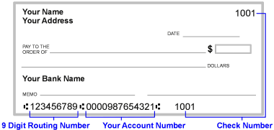
VOID
IMPORTANT: Affix copy of voided check below and fax to 888-498-1118 (secure online fax) or deliver in person to Payment Services, University Gardens Building, Suite 210. Deposits may only be made to checking or share draft accounts. Processing of this request may take up to three (3) weeks.

