Talent Recruitment Campaign of Zhejiang University-UIUC Institute in Southern California

Talent Recruitment seminar will be conducted in the following schedule

Speaker 1: Distinguished Professor and EEIS Program Director Yan XIAO
Biography: Dr. Y. Xiao is currently a Changjiang and Qianren Distinguished Professor, Director of the Energy, Environment and Infrastructure Sciences Program, of ZJU-UIUC Institute. He is a fellow of ASCE and ACI. He is one of the highly-cited scholars in structural engineering and has extensive academic and administrative experiences in USA, China and Japan.

Speaker 2: Distinguished Professor ERPING Li, Dean of ZJU-UIUC Institute, Zhejiang University, China.
Biography: Er-Ping Li is currently a Changjiang Distinguished Professor, Dean of ZJU-UIUC Institute, Zhejiang University, Fellow of IEEE(2007). He authored and coauthored over 400 papers, and two books.

Date: January 30, 2019; Time: 18:00 am-19:00
Venue: KAP209, University of Southern California, Los Angeles, CA90089
(Nearest gate is Gate 6 on Vermont Ave.)
Welcome!

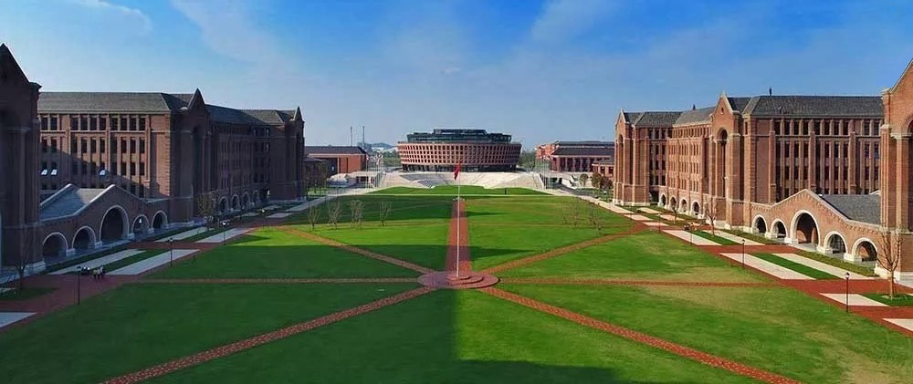
The Institute
The ZJU-UIUC Institute is an engineering college partnership between Zhejiang University and the University of Illinois at Urbana-Champaign under Zhejiang University, it is located on the new Zhejiang University (ZJU) International Campus in Haining, China, about 120 km southwest of Shanghai.

ZJU and UIUC are renowned for their engineering programs and have a long history of collaboration. The ZJU-UIUC Institute breaks boundaries between traditional engineering disciplines, it creates cross-disciplinary teams and activities, and encourages multidisciplinary knowledge convergence and cross cooperation. The ZJU-UIUC Institute conducts teaching and research in broad program themes of engineering and system sciences, information and data sciences, energy, environment, and infrastructure sciences etc. Undergraduate and graduate degrees are offered in civil and environmental engineering, computer engineering, electrical engineering, electronics engineering, and mechanical engineering. Classes and student activities at the ZJU-UIUC Institute are conducted in English. The ZJU-UIUC Institute provide world-class teaching and research facilities. There are all first-rate teaching and research settings.
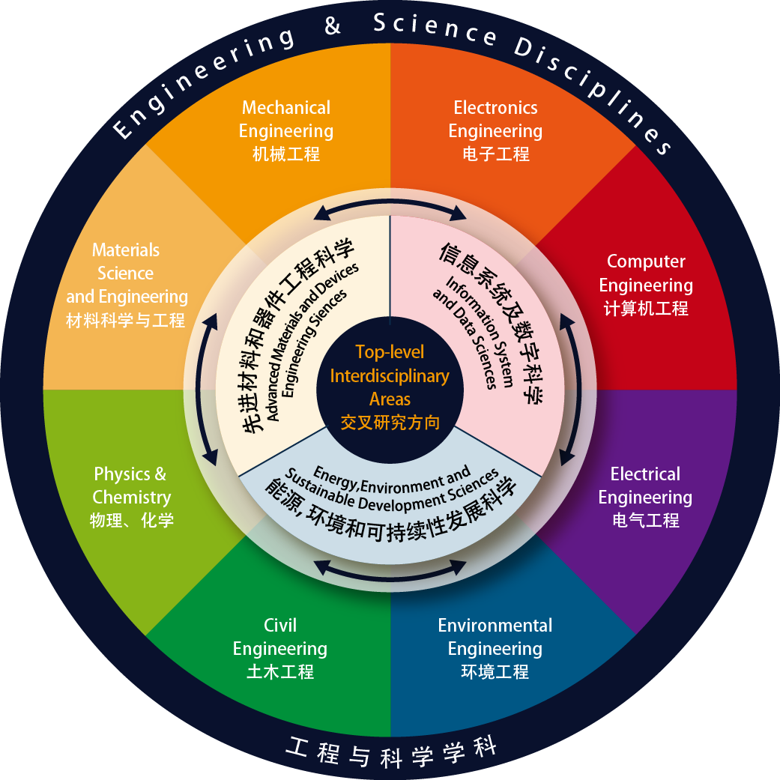
ZJUI welcomes overseas talent to join us and create a brilliant future!

Tenure-Track Faculty / Program Director in Engineering
ZJU-UIUC Institute invites highly qualified candidates for multiple tenured or tenure-track faculty positions at all levels and in areas of engineering and science including electrical engineering, electronic engineering, computer engineering, communications and networks, artificial intelligence, civil and environmental engineering, mechanical engineering and advanced manufacturing and physics, materials science, which match its multidisciplinary mission. Candidates should have exceptional academic record or demonstrate strong potential in the cutting-edge research areas of engineering and science multidisciplinary technologies.

- Assistant professor must have an earned doctorate, excellent academic credentials, strong research plans, and an outstanding ability to teach effectively.

- Associate professor must be established leaders in their field; exhibit strong records of teaching, publication, and funded research; and demonstrate participation in interdisciplinary collaborations.

- Full professor are available for persons of international stature seeking to build substantial interdisciplinary research and teaching programs.

- Program Director (with rank of Department Head) must have at least ten years of progressively more impactful experience following the doctoral degree； Evidence of entrepreneurial impact, and a track record of initiating and leading major research projects and programs；Scholarly publications, and/or equivalent evidence of impact, such as patents and products; a clear ability to develop and execute visionary plans;
-Skills in attracting and recruiting top talent at all levels.

Compensation and benefits
Salary and research initiation support will be commensurate with qualifications and competitive with international norms.

Applications
Application materials should include a cover letter with current contact information including email address, as well as complete curriculum vitae, statements of research and teaching goals, and the names of three or more references. Please submit applications at http://zui.illinois.edu. For more information, please visit job opportunities on http://zjui.zju.edu.cn.

Contact Us
zjuihr@zju.edu.cn

浙江大学伊利诺伊大学联合学院新加坡人才引进洽谈会
李尔平，ZJUI联合学院院长

日期: 2019年1月26日
时间： 10:00 am-1:00 pm
地点: NTU Alumni Club, near Bonavista MRT, 11 Slim Barracks Rise, Singapore, 138664

诚邀感兴趣的嘉宾抽空光临！

一、学院简介
浙江大学伊利诺伊大学厄巴纳香槟校区联合学院（ZJU-UIUC Institute, 简称ZJUI）是浙江大学下属的非独立法人中外合作办学学院，由中外合作方——浙江大学和美国伊利诺伊大学厄巴纳香槟校区共同管理。地处上海以南的浙江海宁市浙江大学国际联合学院（海宁国际校区）。

ZJU-UIUC联合学院依托浙江大学和伊利诺伊大学厄巴纳香槟校区驰名中外的工科专业及长期合作的良好基础进行建设，将在全新的浙江大学国际校区上创造独一无二的世界顶尖的多学科交叉教育与研究平台。 学院小而精，以精细化管理为宗旨，培养学生在科技方面的领导力、团队协作能力，创造卓越的学习体验。联合学院诚邀具有多元背景、经验、理念，认同多元和包容价值观的杰出英才加盟联合学院。

ZJU-UIUC联合学院着重工程科学交叉研究领域，打破传统工程学科界限，不按学科属性设立系、所等机构，建立学科交叉研究平台，鼓励多学科知识融合、交叉合作，主要交叉研究领域包括工程与系统科学、信息与数据科学、能源/环境/基础设施科学等学科。目前开设的本科和研究生专业包括土木工程、电子与计算机工程、电气工程及其自动化、机械工程。ZJU-UIUC联合学院工作语言为英语，授课及学生活动均要求用英文进行， 联合学院具备国际一流的教学及科研环境。

ZJUI联合学院竭诚欢迎海外英才加盟，共创辉煌！

二、招聘学科领域
联合学院诚邀电气、电子、计算机、通信与网络、人工智能、土木与环境、机械与先进制造等相关工程领域及物理和材料科学等跨学科背景的英才加入。特别欢迎数据科学与工程、人工智能、通信与网络、智能电网、交通电气化、纳米技术、生命化工程科学、能源与集成、环境可持续、智能化基础设施、智能制造、先进微纳电子与光电子学、电磁与太赫兹技术、纳米技术、量子信息、新材料等跨学科背景的英才。
学院将优先推荐满足条件的申请者参选“国家青年千人计划”。

三、招聘要求
- 助理教授 —— 候选人学历要求为博士及以上，要求学术成果卓越，研究计划优异，教学能力突出。有相关行业工作经验、博士后经验、专业服务经验或实习经验都将优先考虑。
- 副教授 —— 候选人须在其学术领域有一定的影响力，具有较强的教学能力、丰硕的学术成果及获资助的研究项目，且参与过跨学科的项目合作。
- 教授 —— 候选人须在其学科领域有较高的国际影响力和地位，尤其欢迎正在寻求交叉研究和教学平台的资深学者。
- 各学科系主任---- -在工业界或学术界的领导经历，有影响力的创业或领导过的主要研究项目和计划经历，具有影响力的学术论文或专著，清晰的制定和执行有未来计划的能力，吸引和招募顶尖人才的能力。

四、支持条件
学院将为入选者提供优越的工作和生活条件。
1.具有国际竞争力的薪酬;
2.住房：提供教师公寓租住，符合条件者可申购国际校区人才房1套；
3.科研经费：助理教授及副教授将获学院提供150-400万元启动经费；若申请到青年千人，还可以享受国家提供50万补贴（免税）和100-300万元科研经费及浙江省提供一次性科学技术奖励100万元(免税)。
4.聘任：纳入浙江大学终身轨教师聘任体系；
5.资源配置：博士生、博士后的招收指标和办公及实验面积；
6.保障条件：积极安排子女入学入托，积极协助配偶工作和落户。

五、联系方式
欢迎广大青年人才通过电子邮件、电话等方式与ZJUI联合学院联系并递交应聘材料（材料需全英文），请在http://zjui.illinois.edu 网站上提交申请。全英文申请材料须包含: 求职信（请写明目前的电子邮箱、电话、地址等联系方式）、个人简历、研究和教学目标陈述、三个或三个以上推荐人信息等。更多资讯请浏览http://zjui.zju.edu.cn。非常感谢！

联系我们:
zjuihr@zju.edu.cn

